**01. Introduction**

* 1. **Problem statement**

Seed sowing machine is a device which helps in the sowing of seeds in a desired position hence assisting the farmers in saving time and money. The basic objective of sowing operation is to put the seed and fertilizer in rows at desired depth and seed to seed spacing, cover the seeds with soil and provide proper compaction over the seed. The paper discusses different aspects of seed sowing machine which will be helpful for the agriculture industry to move towards mechanization. The agricultural industry has always been the backbone of India’s sustained growth. As the population of India continues to grow, the demand for produce grows as well. Hence, there is a greater need for multiple cropping on the farms and this in turn requires efficient and high-capacity machines. Mechanization of the Agricultural industry in India is still in a stage of infancy due to the lack of knowledge and the unavailability of advanced tools and machinery. In traditional methods seed sowing is done by broadcasting manually, opening furrows by a plough and dropping seeds by hand.

The agricultural has always been the backbone of India’s sustained growth. As the population of India continues to grow, the demand for produce grows as well. Hence, there is a greater need for multiple cropping in the farms and this in turn requires efficient and time saving machines. The paper discusses different types of seed sowing machine which will be helpful for the agriculture industry to move towards mechanization.

Agricultural implement and machinery program of the government has been one of selective mechanization with a view to optimize the use of human, animal and other sources of power. In order to meet the requirements, steps were taken to increase availability of implements, irrigation pumps, tractors, power tillers, combine harvesters and other power operated machines and also to increase the production and availability of improved animal drawn implements. Special emphasis was laid on the later as more than 70% of the farmers fall in small and, marginal category. It is generally said that mechanization of small farms is difficult. But Japan having average land holding even smaller than ours, with proper mechanization has led agriculture to great heights. In order to minimize the drudgery of small farmers, to increase efficiency and save farmer's time for taking up additional /supplementary generating activities, the use of modern time saving machines/implements of appropriate size needed to be suitably promoted.

**1.2 Objectives**

Objective of the project can be stated as

1. Investigation of various types of seed sowing and fertilizer spraying machine
2. Development of solar powered seed sowing and fertilizer spraying machine.
3. Testing of development of solar powered seed sowing and fertilizer spraying machine in actual agricultural farm.

**1.3 Scope**

Seed sowing machine is a device which helps in the sowing of seeds in a desired position hence assisting the farmers in saving time and money. So considering these points related to spraying and seed sowing an attempt is made to design and fabricate such equipment which will able to perform both the operations more efficiently and also will results in low cost. Decrease the operational cost by using new mechanism.

• Work reliably under different working conditions.

• Decrease the cost of machine.

• Decrease labor cost by advancing the spraying method.

• Machine can be operated in small farming land (1 acre).

• Making such a machine which can be able to perform both the operation

**1.4 Methodology**

Spraying and seed sowing an attempt is made to design and fabricate such equipment which will able to perform both the operations more efficiently and also will results in low efforts. Now the project mainly concentrates on designing a suitable operating system. To maintain simplicity and economy in the design the locally fabricated unit has been used. Our project achieves higher safety, reduces human effort, increases the efficiency, reduces the work load, reduces the fatigue of workers and reduces maintenance cost.

**1.5 Objective of the project**

* To understand the basic principal of the our project
* Describe the construction and working of various parts of our project
* Development of the working model of the our project

**02. Construction & Working of Project**

In our country farming is done by traditional way, be sides that there is large development of industrial and service sector as compared to that of agriculture. The spraying is traditionally done by labour carrying backpack type sprayer which requires more human effort. The weeding is generally done with the help of Bulls which becomes costly for farmers having small farming land. So to overcome these above two problems, we tried to eliminate these problems and designed the equipment which will be beneficial to the farmer for the spraying and weeding operations.

**2.1 Selection of Sowing and Planting Machines**

Different designs of improved seed drills/planters have been developed for sowing of crops. Basic difference in the design of these seed drills is mainly in the type of seed metering mechanism and furrow openers. Therefore, it is essential to select the machine with a metering unit and furrow opener suitable for the crop and soil conditions.

**2.2 Parts used in the project**

**2.2.1 Solar plate:-**

A solar plate consists of photovoltaic (PV) cells. Solar radiations can be converted directly in to the electricity using these photovoltaic (PV) cells. When sunlight falls on solar plate a part of light is absorbed and is converted into electrical energy by means of electron movement’s .The majority of solar panels use wafer based crystalline silicon cells or thin film cells based on silicon. The structural load carrying member can either be top layer or bottom layer. Cells must also be provided from mechanical damage and moisture. Some recent solar plate design includes concentrators in which light is focused by lenses or mirrors on solar cells. This enables the use of cells in an effective manner.

Depending on construction, photovoltaic cells can produce electricity from range of frequencies of light, but usually cannot cover entire solar range specially ultraviolet, infrared and low or diffused light. Hence, much of incident light energy is wasted by solar cells and they can give far higher efficiencies. Therefore another design concept is to split the light into different wavelength ranges and direct the beams onto different cells tuned to these ranges. This has been projected to be capable of raising the efficiency by almost 50%. Currently the best achieved sunlight conversion rate is around 21.5%. The largest challenge of photovoltaic technology is the efficiencies of such solar systems. Solar plates must withstand rain and cycles of heat and cold for many years. Solar panel conversion efficiency typically in the 20 percent range, is reduced by dust and other particulates that accumulate on solar panel. The basis of producing solar panels revolves around the use of silicon cells which are not efficient enough in their current state and can only convert solar energy into usable power at rate of 20-25%.

**2.2.2 Battery:-**

An electric battery is a device consisting of one or more electrochemical cells that convert stored chemical energy into electrical energy. Each cell contains a positive terminal, or cathode, and a negative terminal, or anode. Electrolytes allow ions to move between the electrodes and terminals, which allows current to flow out of the battery to perform work. Battery can be charged by solar panel available on top of sprayer and is connected in series with it. Battery can be charged continuously during discharge itself, by attaching the banal on the sprayers.

**2.2.3 Wiper Motor:-**

An electric motor is a device used to convert electrical energy to mechanical energy. Electric motors are extremely important in modern-day life. The basic principle on which motors operate is Ampere's law. This law states that a wire carrying an electric current produces a magnetic field around itself. A wiper motor is a DC motor with two permanent magnets that serves as field for the motor, arranged around the armature where power is connected to armature with the help of brushes.

**2.2.4 Diaphragm Pump :-**

A pump is a device that moves fluid by mechanical action. Pumps operate by some mechanism and consume energy to perform work by moving the fluid. The energy used by pump to operate is electrical energy.A diaphragm pump is a positive displacement pump that uses a combination of the reciprocating action of a rubber, thermoplastic and suitable valves on either side to pump a fluid. When a volume of a chamber of pump is increased the pressure decreases and the fluid is drawn into the chamber. When the chamber pressure later increases from decreased volume the fluid previously drawn into the chamber is forced out. Finally the diaphragm moving up once again draws fluid into the chamber, completing the cycle.

**2.3 Diagram of the project**

Supporting frame & Structure

Battery

Motor

Front Wheel

Rear Wheel

Seed drilling pipe

Button on /off

Seed box

Chain drive

Chain & Sprocket

**2.4 Working of the project**

As the solar plate receives light energy from the sun which is reflected on the photovoltaic cells this generates the electrical energy from the solar energy. This electrical energy generated by solar plate is given to the battery which is dischargeable in nature and connected in series with the solar plate. As battery receives energy from solar plate it starts charging, it will be charged fully according to the output of solar plate which depends on the sun light received by solar plate which may vary with atmospheric conditions.

The output terminals of the battery are connected to the motor. So the motor receives the input from battery as the battery acquires some charge. It is important to know that battery can be charged during its discharge also. Motor provides drive to the front wheel of chassis so as to drive the unit further. Motor also provide drive to the pump which is used to pump the liquid from the container placed on the chassis. For spraying the fertilizers the spray is made on by using a button provided for switching the spray on and off. Thus the fertilizers can be sprayed to the crops more easily and conveniently.

For seed sowing, a chain is provided in between front wheel and the rear wheel of chassis. A chain and sprocket is provided between rear wheels and seed box so according to motion of wheel in further movement seed will come in seed drilling pipe. From this seed drilling pipe seeds are sowed in ground.

**03 Design and design consideration of the project**

**3.1. Design consideration of the project**

Project design may be defined as the iterative decision making activity to create a plan or plans by which the available resources are converted, preferably optimally, into systems, processes or devices to perform the desired functions and to meet human needs. In fact project design has been defined in many ways but the simplest ways to define project design as Project design may be defined as the iterative decision making activity to create a plan or plans by which the available resources are converted, preferably optimally, into systems, processes or devices to perform the desired functions and to meet human needs. In fact project design has been defined in many ways but the simplest ways to define project design as

“An iterative decision making process to conceive and implement optimum systems to solve society’s problems and needs.”

Project design is practical in nature and must be concerned with physical reliability, or economic and financial feasibility Design is essentially a decision-making process. If we have a problem, we need to design a solution. In other words, to design is to formulate a plan to satisfy a particular need and to create something with a physical reality.

**3.1.1 Factors to be considered in project design**

There are many factors to be considered while attacking a design problem. In many cases these are a common sense approach to solving a problem. Some of these factors are as follows:

1. What device or mechanism to be used? This would decide the relative arrangement of the constituent elements.
2. Material
3. Forces on the elements
4. Size, shape and space requirements. The final weight of the product is also a major concern.
5. The method of manufacturing the components and their assembly.
6. How will it operate?
7. Reliability and safety aspects
8. Inspectibility
9. Maintenance, cost and aesthetics of the designed product.

* **What device or mechanism to be used**

This is best judged by understanding the problem thoroughly. Sometimes a particular function can be achieved by a number of means or by using different mechanisms and the designer has to decide which one is most effective under the circumstances. A rough design or layout diagram may be made to crystallize the thoughts regarding the relative arrangement of the elements.

* **Material:**

This is a very important aspect of any design. A wrong choice of material may lead to failure, over or undersized product or expensive items. The choice of materials is thus dependent on suitable properties of the material for each component, their suitability of fabrication or manufacture and the cost.

* **Load:**

The external loads cause internal stresses in the elements and these stresses must be determined accurately since these will be used in determining the component size. Loading may be due to:

* 1. Energy transmission by a project member.
  2. Dead weight.

1. Inertial forces.
2. Thermal effects.
   1. Frictional forces.

**3.1.2 Steps in project design**

Project Design or mechanical design is primarily concerned with the systems by which the energy is converted into useful mechanical forms and of mechanisms required to convert the output of the project to the desired form. The design may lead to an entirely new project or an improvement on an existing one. Thus project design is the production or creation of the right combination of correctly proportioned moving and stationary components so constructed and joined as to enable the liberation, transformation, and utilization of energy.

The basic procedure of project design (Mechanical Project Design) consists of a step by step approach from given specifications of functional requirement of a product to the complete description in the form of blue prints of the final product. The following steps are involved:

**First Step**

In the very first step a complete list of specifications for the functional requirement of the product is to be prepared. The requirement may include, for example:

1. Output capacity;
2. Service life;
3. Cost;
4. Reliability; etc.

In consumer products, in addition appearance, noiseless operation, and simplicity in control are important requirements. Depending upon the type of product, various requirements are given Weight age and a priority list of specifications is prepared.

**Second Step**

After a careful study of the requirements the designer prepares rough sketches of different possible mechanisms of project and depending upon the cost competitiveness, availability of raw material, and manufacturing facilities, the possible mechanisms are compared with each other and the designer selects the best possible mechanism for the product

**Third Step:**

In the third step of the design procedure a block diagram is to be prepared which showing the general layout of the selected configuration. In this step designer specifies the joining methods, such as riveting, bolting, and welding to connect the individual components. Rough sketches of shapes of individual parts are prepared.

**Fourth Step**

* After selecting the required or deciding the configuration of mechanism / project in third step above. The design of individual components of the selected configuration is to be done in this step. It consists of the following stages:
* Determine the forces acting on each component;
* Selecting the proper material for the component depending upon the functional requirement, such as strength, wear, rigidity, hardness and bearing properties etc.
* Determine the likely mode of failure & select the criterion of failure like, yield strength, ultimate strength, deflection etc.
* Determine the geometric dimensions of the components using suitable factor of safety and modify the dimensions from manufacturing considerations. This stage involves the detailed stress analysis.

**Fifth Step:**

* The last stage in design process is to prepare the blue prints of assembly and individual component. On these drawings, the material of the components, dimensions and tolerances, surface finish and machining methods are specified.
* The designer prepare two separate lists of components
* Standard components to be purchased directly from the market
* Special components to be projects in the factory; Thus the project design or mechanical design process is a systematic step-by-step approach from known specification to unknown solution

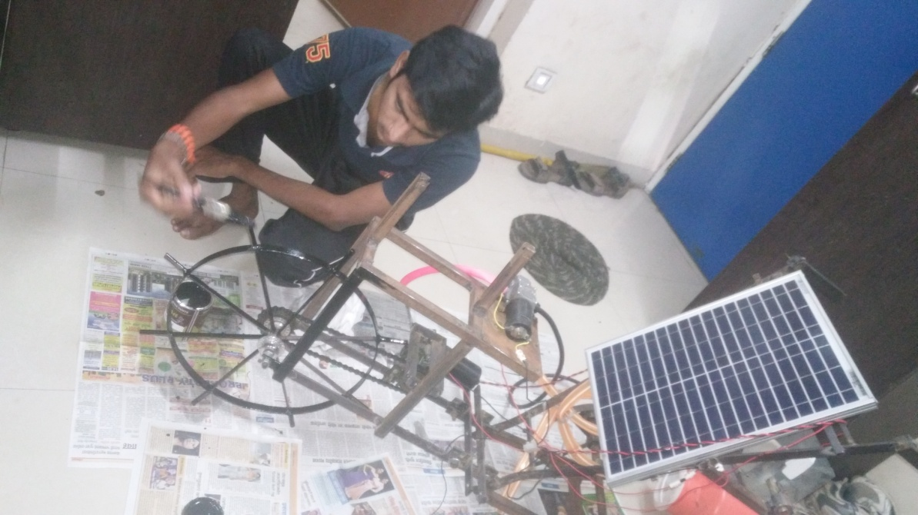

**3.1.3 Planning for project design**

Project design is the chronological vertical structure of the various phases or steps together from the project analysis to the retirement of the product. Thus Project of design includes the following steps:

**Feasibility Study**

The aim is to produce a number of feasible and useful solutions. Here the alternatives are assessed in stages. The first stage is made on the basis of common sense. Many of the broad solutions may not be worth consideration. Considering technical feasibility some of the solutions can be eliminated. The last stage is the economic assessment. Systematic technical, economic, social and legal considerations provide a rapid convergence towards the useful solutions.

**Preliminary Design**

Feasibility study yields a set of useful solutions. The aim in this phase is to choose the optimal solution. To do this, criterion of optimization must be explicitly delineated. The chosen alternative is then tested and predictions are made concerning its performance.

**Detailed Design**

The purpose of the detailed design is to produce a complete project description of a tested and producible design for manufacture. A detailed design includes manufacturing drawings with tolerances. Planning for Manufacturing- A procedure sheet is to be made which contains a sequence of manufacturing operations that must be performed on the component. It specifies clearly the tooling, fixtures and production projects. This phase may include planning, and inventory control, quality control system, the fixing of standard time and labour cost for each operation.

**Planning for Distribution, Use of the Product**

The success of a design depends on the skill exercised in marketing the product. Also the user-oriented concern such as reliability, ease of maintenance, product safety, and convenience in use, aesthetic appeal, economy and durability must meet. The product life considering actual wear or deterioration, and technological obsolescence must be planned.

**3.2 Design of the project**

**3.2.1 Design or selection of various parts used the project**

**Selection solar panel**

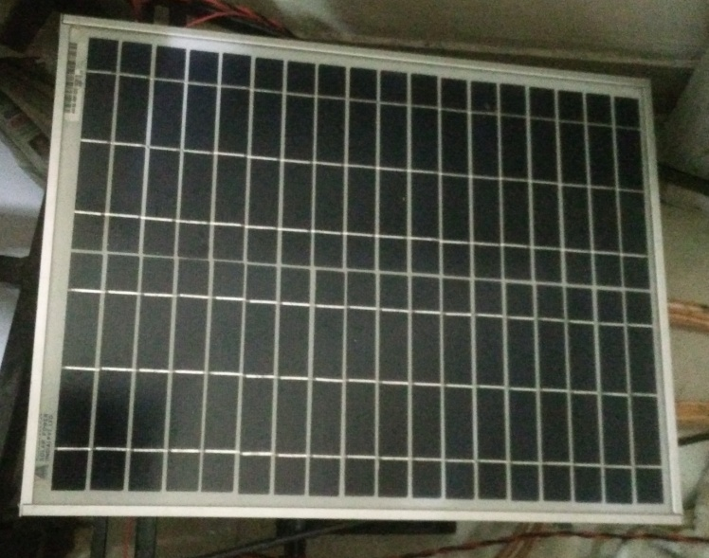

**Solar panel Specification**

|  |  |  |  |  |  |  |  |
| --- | --- | --- | --- | --- | --- | --- | --- |
| P max (Wp) | Vmax (v) | Imax (A) | Voc (v) | Isc (A) | Module Size (mm) | Weight (kg) | Efficiency (%) |
| 20 | 12.60 | 1.14 | 21.50 | 1.23 | 555X340X22 | 2.1 | 10.5 |

* **As per solar panel specification Imax is 1.14 (A)**

Solar panels are a great way of cutting your electricity We all want to live self-sustainably, or at least reduce the carbon footprint of our home, and solar panels make that dream possible. Solar panels are made of photovoltaic (PV) cells, which turn sunlight into electricity. This electricity can then be fed into your home's mains electricity supply.

The technology behind solar is relatively old, despite their futuristic appeal, but while the basics are the same the efficiency of solar panels has improved greatly in recent years. Rated power 20W Frame Heavy duty aluminium Kind of connection waterproof junction box, can be customized Guarantee of power 90% within 10 years 80 within 25 years, Kind of glass and its thickness Low Iron, high transparency tempered glass of 3.2mm SLA Battery Voltage 12V size 555X340X22

**3.2.2 Selection of Battery**

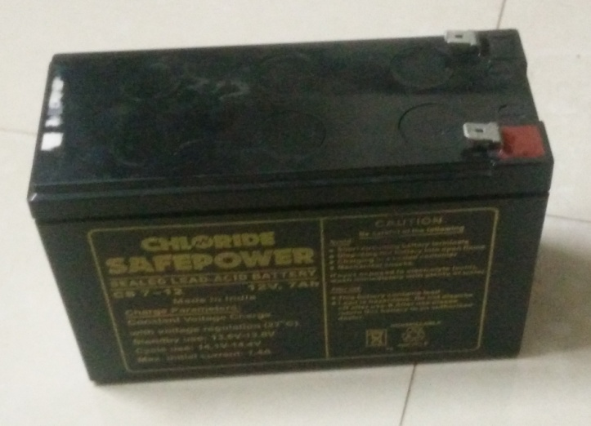

An electric battery is a device consisting of one or more electrochemical cells that convert stored chemical energy into electrical energy. Each cell contains a positive terminal, or cathode, and a negative terminal, or anode. Electrolytes allow ions to move between the electrodes and terminals, which allows current to flow out of the battery to perform work**.**

Battery: 7.2 Amp Hour 12 Volts Sealed Lead Acid Battery

**3.2.3 Selection of Motor as battery specification**

Motor 12V DC 30 RPM

An electric motor is a machine which converts electric energy into mechanical energy. Its action is based on the principle that when a current carrying conductor is placed in magnetic field, it experiences a mechanical force whose direction is given Fleming’s Left Hand Rule.

* **Design of the Motor**

We know,

Specification of the DC motor,

Toque (T) = 5 N-m

Speed (N) = 30 rpm

We know,

Power (P) = 2πNT/60

= (2×3.14×30×5)/60

= 15.7 watt

Power of the motor (P) = 15.7 watt.

**3.2.4 Chassis:**

A consists of an internal framework that supports a man-made object in its construction and use. It is analogous to an animal's skeleton. An example of a chassis is the under part of a motor vehicle, consisting of the frame (on which the body is mounted). If the running gear such as wheels is included then the assembly is described as a rolling chassis. Material Used In Chassis – Iron

Size of Chassis – 22 inch x 8 inch x 36 inches

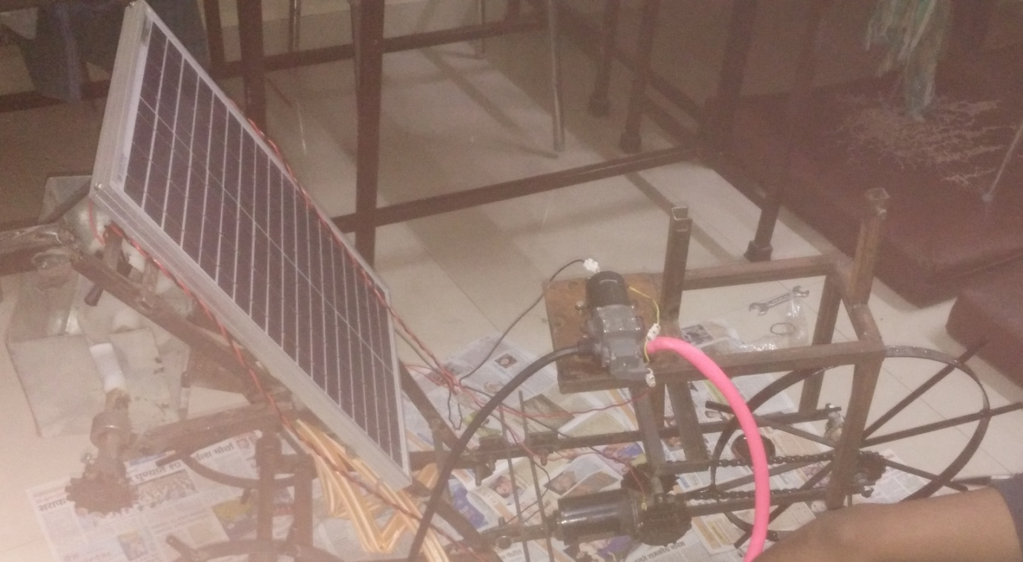

**3.2.5 Battery Charging Design**

**Charging time of the battery:**

Charging time was computed by taking the ratio rating of battery in ampere hour (Ah) to the total current consumed by the solar panel.

Charging Time = (battery rating in ampere hour)/ (total current consumed by the solar panel)

Therefore,

Charging Time =7.5/1.1 =6.81 hours

**Discharging Time of battery:**

In case of spraying

Motor current: 2.4A

Pump Current:1A

Total Current :3.4A

Therefore Discharging Time = (battery rating in ampere hour) / Total Current

= 7.5 / 3.4

= 2.2 hours

In case when only seed sowing is done

Current rating: 2.4A

Therefore discharging time = 7.5 / 2.4

= 3.125 hours

**3.2.6 Diaphragm Pump**

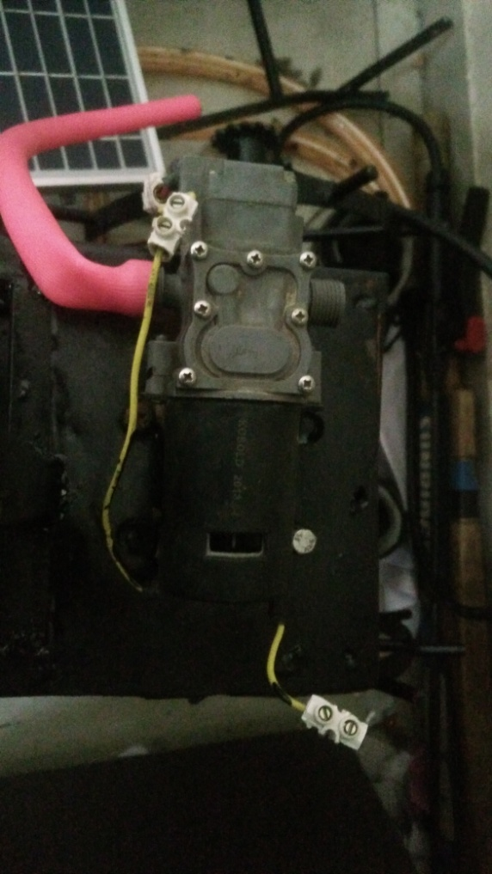

In dc system for irrigation purpose and small scale application diaphragm pump is mostly used because of its high efficiency and low rating. It gives constant output for the applications like spray pump. It is available in very small sizes that's why we have choosen this pump for spraying application.

**04 Manufacturing process of the project**

Manufacturing is the backbone of any industrialized nation. Manufacturing and technical staff in industry must know the various manufacturing processes, materials being processed, tools and equipment’s for manufacturing different components or products with optimal process plan using proper precautions and specified safety rules to avoid accidents. Beside above, all kinds of the future engineers must know the basic requirements of workshop activities in term of man, machine, material, methods, money and other infrastructure facilities needed to be positioned properly for optimal shop layouts or plant layout and other support services effectively adjusted or located in the industry or plant within a well-planned manufacturing organization.

The complete understanding of basic manufacturing processes and workshop technology is highly difficult for anyone to claim expertise over it. The study deals with several aspects of workshops practices also for imparting the basic working knowledge of the different engineering materials, tools, equipment’s, manufacturing processes, basic concepts of electro-mechanical controls of machine tools, production criteria’s, characteristics and uses of various testing instruments and measuring or inspecting devices for checking components or products manufactured in various manufacturing shops in an industrial environment. It also describes and demonstrates the use of different hand tools (measuring, marking, holding and supporting tools, cutting etc.), equipment’s, machinery and various methods of manufacturing that facilitate shaping or forming the different existing raw materials into suitable usable forms. It deals with the study of industrial environment which involves the practical knowledge in the area of ferrous and non ferrous materials, their properties and uses. It should provide the knowledge of basic workshop processes namely bench work and fitting, sheet metal, carpentry, pattern making, mould making, foundry, smithy, forging, metal working and heat treatment, welding, fastening, machine shop, surface finishing and coatings, assembling inspection and quality control. It emphasizes on basic knowledge regarding composition, properties and uses of different raw materials, various production processes, replacement of or improvement over a large number of old processes, new and compact designs, better accuracy in dimensions, quicker methods of production, better surface finishes, more alternatives to the existing materials and tooling systems, automatic and numerical control systems, higher mechanization and greater output.

Manufacturing is derived from the Latin word manufactus, means made by hand. In modern context it involves making products from raw material by using various processes, by making use of hand tools, machinery or even computers. It is therefore a study of the processes required to make parts and to assemble them in machines. Process Engineering, in its application to engineering industries, shows how the different problems related to development of various machines may be solved by a study of physical, chemical and other laws governing the manufacturing process. The study of manufacturing reveals those parameters which can be most efficiently being influenced to increase production and raise its accuracy.

**4.1 Manufacturing Process**

Manufacturing process is that part of the production process which is directly concerned with the change of form or dimensions of the part being produced. It does not include the transportation, handling or storage of parts, as they are not directly concerned with the changes into the form or dimensions of the part produced.

**4.1.1 Classification of Manufacturing Processes**

In the manufacturing processes used in manufacturing concern for changing the ingots into usable products may be classified into six major groups as primary shaping processes, secondary machining processes, metal forming processes, joining processes, surface finishing processes and processes effecting change in properties. These are discussed as under.

* **Primary Shaping Processes**

Primary shaping processes are manufacturing of a product from an amorphous material. Some processes produces finish products or articles into its usual form whereas others do not, and require further working to finish component to the desired shape and size. Castings need re-melting of scrap and defective ingots in cupola or in some other melting furnace and then pouring of the molten metal into sand or metallic moulds to obtain the castings. The parts produced through these processes may or may not require undergoing further operations.

Some of the important primary shaping processes is:

* Casting
* Powder metallurgy
* Plastic technology
* Cutting
* Bending
* Forging.
* **Secondary or Machining Processes**
* Turning
* Threading
* welding
* Drilling
* Planning
* Shaping
* Slotting
* Grinding
* Thread cutting
* Unconventional machining processes namely machining with Numerical Control (NC) machines tools or Computer Numerical Control (CNC) machines tools using ECM, LBM, AJM, USM setups etc.

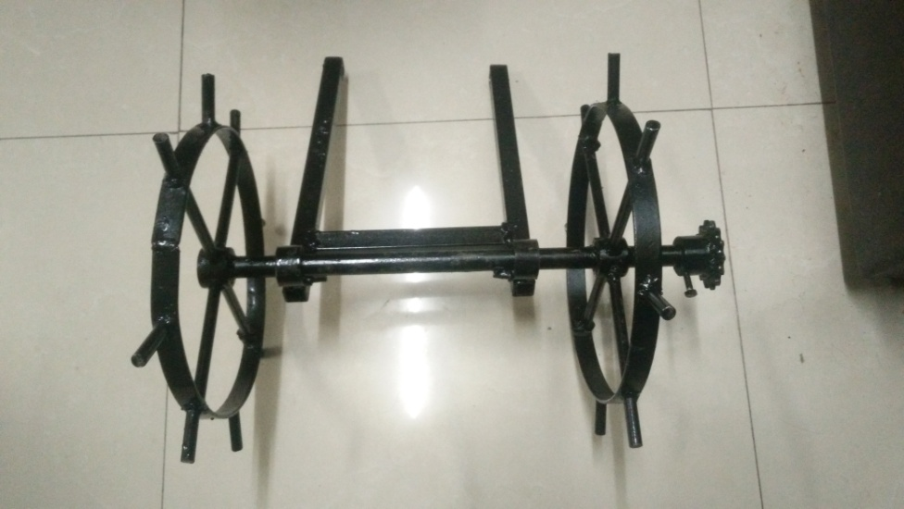

**4.2 Product development process**

A product development has to go through the following concepts of product engineering which are given as under.

* Product functions
* Product specifications
* Conceptual design
* Ergonomics and aesthetics
* Standards
* Detailed design
* Prototype development
* Testing
* Simulation
* Design for manufacture
* Design for assembly
* Drafting

**4.3 Manufacturing process of the project**

**4.3.1 Measurement of the material required dimension:**

Measurement is the foundation of scientific inquiry. In order to test our hypotheses, we must observe our theoretical concepts at the operational level. In simple words, we must measure what we have defined. But there are different levels of measurement, which provide differing amounts of information about the theoretical construct. There are also some basic issues about the adequacy of measurement which we must address.

**4.3.2 Cutting operation as per dimension:**

Cutting processes work by causing fracture of the material that is processed. Usually, the portion that is fractured away is in small sized pieces, called chips. Common cutting processes include sawing, shaping (or planning), broaching, drilling, grinding, turning and milling. Although the actual machines, tools and processes for cutting look very different from each other, the basic mechanism for causing the fracture can be understood by just a simple model called for orthogonal cutting.

In all machining processes, the workpiece is a shape that can entirely cover the final part shape. The objective is to cut away the excess material and obtain the final part. This cutting usually requires to be completed in several steps – in each step, the part is held in a fixture, and the exposed portion can be accessed by the tool to machine in that portion. Common fixtures include vise, clamps, 3-jaw or 4-jaw chucks, etc. Each position of holding the part is called a setup. One or more cutting operations may be performed, using one or more cutting tools, in each setup.

**4.3.3 Machining operation on required parts:**

Turning is a cutting operation in which the part is rotated as the tool is held against it on a machine called a lathe. The raw stock that is used on a lathe is usually cylindrical, and the parts that are machined on it are rotational parts – mathematically, each surface machined on a lathe is a surface of revolution. Machining is an essential process of finishing by which work pieces are produced to the desired dimensions and surface finish by gradually removing the excess material from the preformed blank in the form of chips with the help of cutting tool(s) moved past the work surface(s).Most of the engineering components such as gears, bearings, clutches, tools, screws and nuts etc. need dimensional and form accuracy and good surface finish for serving their purposes. Performing like casting, forging etc. generally cannot provide the desired accuracy and finish. For that such preformed parts, called blanks, need semi-finishing and finishing and it is done by machining and grinding.

* Grinding is also basically a machining process.
* Machining to high accuracy and finish essentially enables a product:
* Fulfill its functional requirements.
* Improve its performance.
* Prolong its service

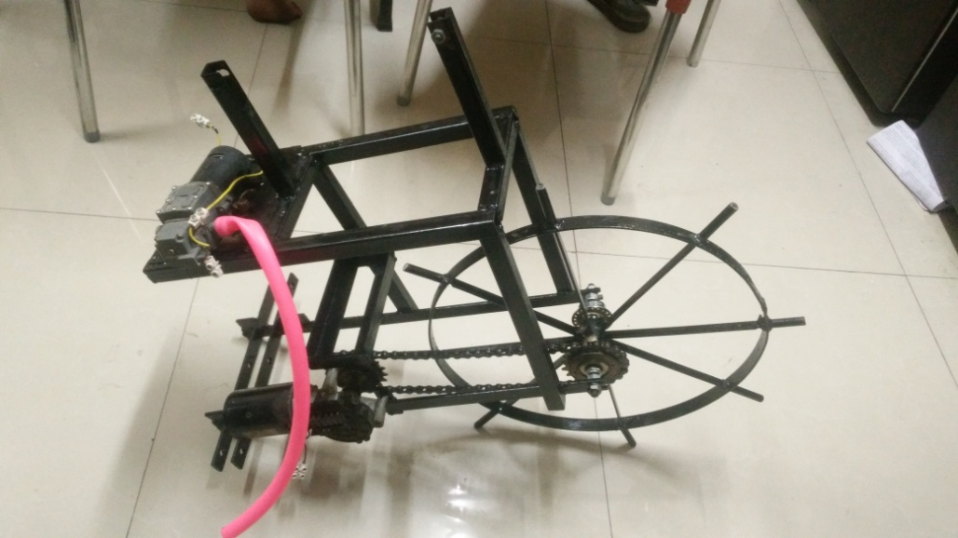

**4.3.4 Drilling and tapping the material as per dimension:**

These four methods all produce holes of different types. Drilling produces round holes of different types; reaming is used to improve the dimensional tolerance on a drilled hole; boring uses a special machine operating like a lathe, to cut high precision holes; and tapping creates screw-threads in drilled holes. Drilling: The geometry of the common twist drill tool (called drill bit) is complex; it has straight cutting teeth at the bottom – these teeth do most of the metal cutting, and it has curved cutting teeth along its cylindrical surface. The grooves created by the helical teeth are called flutes, and are useful in pushing the chips out from the hole as it is being machined. Clearly, the velocity of the tip of the drill is zero, and so this region of the tool cannot do much cutting. Therefore it is common to machine a small hole in the material, called a center-hole, before utilizing the drill. Center-holes are made by special drills called center-drills; they also provide a good way for the drill bit to get aligned with the location of the center of the hole. There are hundreds of different types of drill shapes and sizes; here, we will only restrict ourselves to some general facts about drills.

* Common drill bit materials include hardened steel (High Speed Steel, Titanium Nitride coated steel); for cutting harder materials, drills with hard inserts, e.g. carbide or CBN inserts, are used;
* In general, drills for cutting softer materials have smaller point angle, while those for cutting hard and brittle materials have larger point angle;
* If the Length/Diameter ratio of the hole to be machined is large, then we need a special guiding support for the drill, which itself has to be very long; such operations are called gun-drilling. This process is used for holes with diameter of few mm or more, and L/D ratio up to 300. These are used for making barrels of guns;
* Drilling is not useful for very small diameter holes (e.g. < 0.5 mm), since the tool may break and get stuck in the workpieces;
* Usually, the size of the hole made by a drill is slightly larger than the measured diameter of the drill – this is mainly because of vibration of the tool spindle as it rotates, possible misalignment of the drill with the spindle axis, and some other factors;
* For tight dimension control on hole diameter, we first drill a hole that is slightly smaller than required size (e.g. 0.25 mm smaller), and then use a special type of drill called a reamer. Reaming has very low material removal rate, low depth of cut, but gives good dimension accuracy;
* Large and deep holes are made by spade drills;

**4.3.5 Welding the material as per dimension:**

Welding is a process for joining two similar or dissimilar metals by fusion. It joins different metals/alloys, with or without the application of pressure and with or without the use of filler metal. The fusion of metal takes place by means of heat. The heat may be generated either from combustion of gases, electric arc, electric resistance or by chemical reaction. During some type of welding processes, pressure may also be employed, but this is not an essential requirement for all welding processes. Welding provides a permanent joint but it normally affects the metallurgy of the components. It is therefore usually accompanied by post weld heat treatment for most of the critical components. The welding is widely used as a fabrication and repairing process in industries. Some of the typical applications of welding include the fabrication of ships, pressure vessels, automobile bodies, off-shore platform, bridges, welded pipes, sealing of nuclear fuel and explosives, etc. Most of the metals and alloys can be welded by one type of welding process or the other. 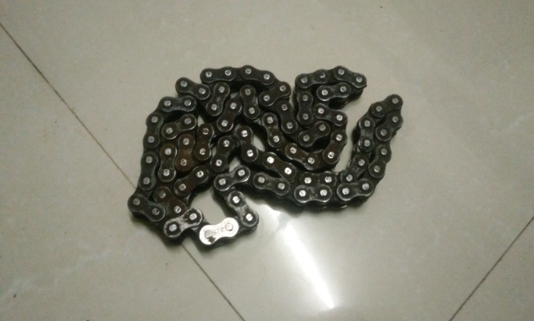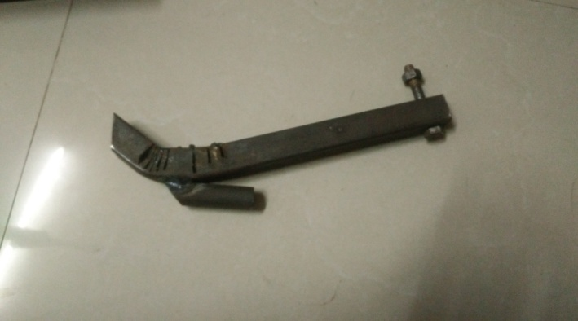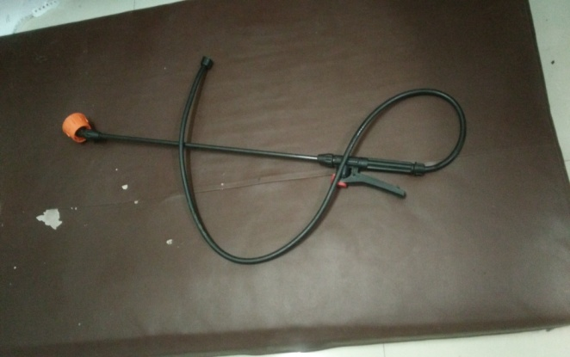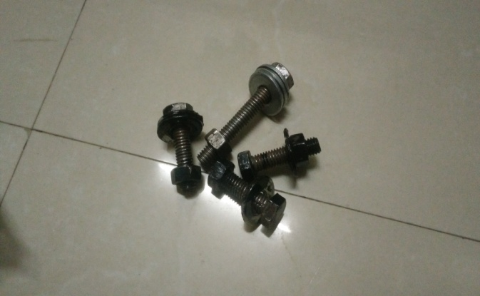

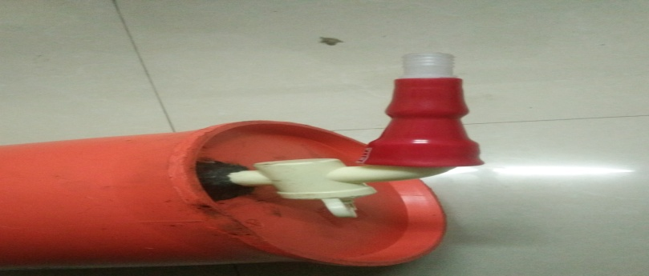

**05. and Application of the project**

**5.1 of the project**

Advantages of the project as per following like as:

* No conventional grid electricity required
* Long operating life
* Highly reliable and durable
* Easy to operate and maintain
* Eco-friendl

**5.3 Application of the project**

Our project should use for following various applications like as:

* Industrial purpose
* Agricultural purpose
* Domestic purpose

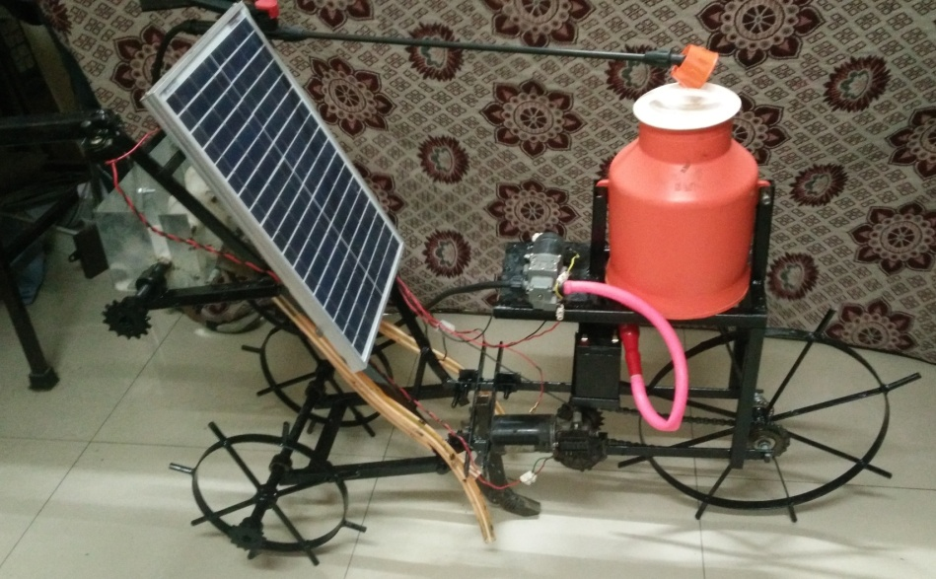

**06 Cost Of The Project**

|  |  |  |  |
| --- | --- | --- | --- |
| **Sr.No.** | **Material with specifications** | **Quantity** | **Cost (Rs)** |
|  | **Solar plate-(12V,20W)** | **01** | **1200** |
|  | **Battery-(12V,7.5A)** | **01** | **750** |
|  | **Wiper motor-(12V dc, 45rpm, 5N.m.)** | **01** | **800** |
|  | **Diaphragm pump-(12V, 0.49Mpa)** | **01** | **1000** |
|  | **Nozzle** | **01** | **30** |
|  | **Chain drive-(25m/s,100KW)** | **02** | **250** |
|  | **Iron hollow pipe** | **10 feet** | **200** |
|  | **Iron rod** | **15 feet** | **300** |
|  | **Extra iron material** | **-** | **2000** |
|  | **Spray unit** | **01** | **110** |
|  | **Water tank-5 lit.** | **1** | **120** |
|  | **Shaft (wheel)** | **2** | **150** |
|  | **Seed Sowing Mechanism** | **1** | **400** |
|  | **Sprocket** | **3** | **150** |
|  | **Seed box** | **1** | **70** |
|  | **Connecting Wires** | **10m** | **100** |
|  | **Contactors and Diode** | **6** | **60** |
|  | **Switches** | **2** | **30** |
|  | **Pipe ( Rubber)** | **10 Feet** | **100** |
|  | **Welding Electrodes** | **1 Box** | **450** |
|  | **Nut and Bolts** | **10** | **100** |
|  | **Paint** | **500ml** | **100** |
|  | **Spanners** | **2** | **80** |
| **Total** | | | **9740/-** |

**07 Reference**

**A] Book Reference**

* R.S. Khurmi and Gupta, “Machine Design” 14th edition, S. Chand
* Richard G. Budynas and J. Keith Nisbett “Mechanical Engineering Design” 9th edition, Tata McGraw Hill
* Hall, Holowenko, Laughlin “Theory and problems of Machine Design” Reprint 2005 edition, McGraw Hill
* Theraja B. L, “Fundamentals of Electrical and Electronics Engineering” S. Chand and company LTD
* K. Sawney, “Electrical and Electronic Measuring Instruments”, Dhanpat Rai and sons.
* Thomas Malvino, “Electronic Principles”, Tata McGraw hill Publishing Company Ltd
* V. K. Mehta, “Principles of Electrical and Electronics Engineering” S. Chand and company Ltd.